Materials in electrostatic field
1. Electrostatic equilibrium
(1)Properties:
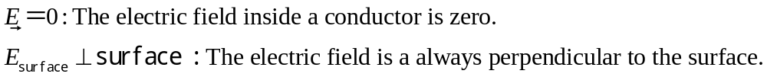
Conclusion ：A conductor is an equipotential object.
(2) charge distribution under electrostatic equilibrium
(a) For solid conductor ：Induced charges only distribute on the surface.
(b) For the conductor which has cavity inside
*No charges in the cavity
No charges on the inner surface; charges only on the outer surface.
*Charges q in the cavity, The conductor carries charges Q initially
Conclusion：inner surface: -q
outer surface: Q+q

(3) Electric field near any conducting surface
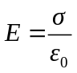
2. Dielectrics in electrostatic field
Polar dielectricsOrientation polarization
Nonpolar dielectricsDisplacement polarization
Polarization charges or bound charges
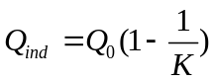
3. Gauss’s law in dielectrics
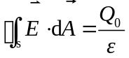
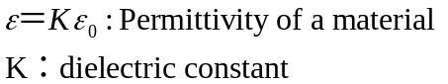

4. capacitor
(1) definition ：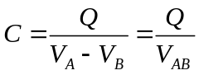
The capacitance C does not depend on Q or V and depends only on the size, shape, and relative position of the two conductors and also on the materials between them.

Calculate capacitance：(a)assume charge 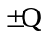
(b)determine the distribution of electrioc field

(c)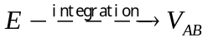
(d)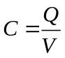，cancle off Q
Application
(a)parallel-plate capacitor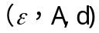：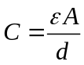
(b)Cylindrical capacitor 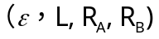： 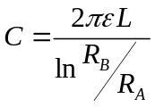
(c)spherical capacitor 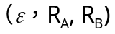： 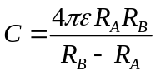
(d) Single isolated spherical capacitor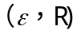： 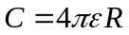
(2) Capacitors in series and parallel
A series combination：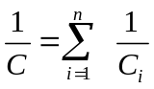
A parallel combination：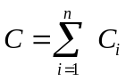
5. Electric field energy
(1)Electric field energy in terms of self-inductance
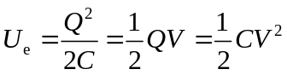
(2)Electric field energy in terms of in terms of Electric field energy density
